# INTRODUCTION

* 1. Overview

A leading web designing company and digital marketing agency with unmatched capabilities and background of building strategies.

* 1. Purpose
  2. We provide end to end solutions for all your business needs including web application, e-commerce website, mobile apps and customer’s software documents.

1. **Problem Definition & Design Thinking**
   1. Empathy Map
   2. 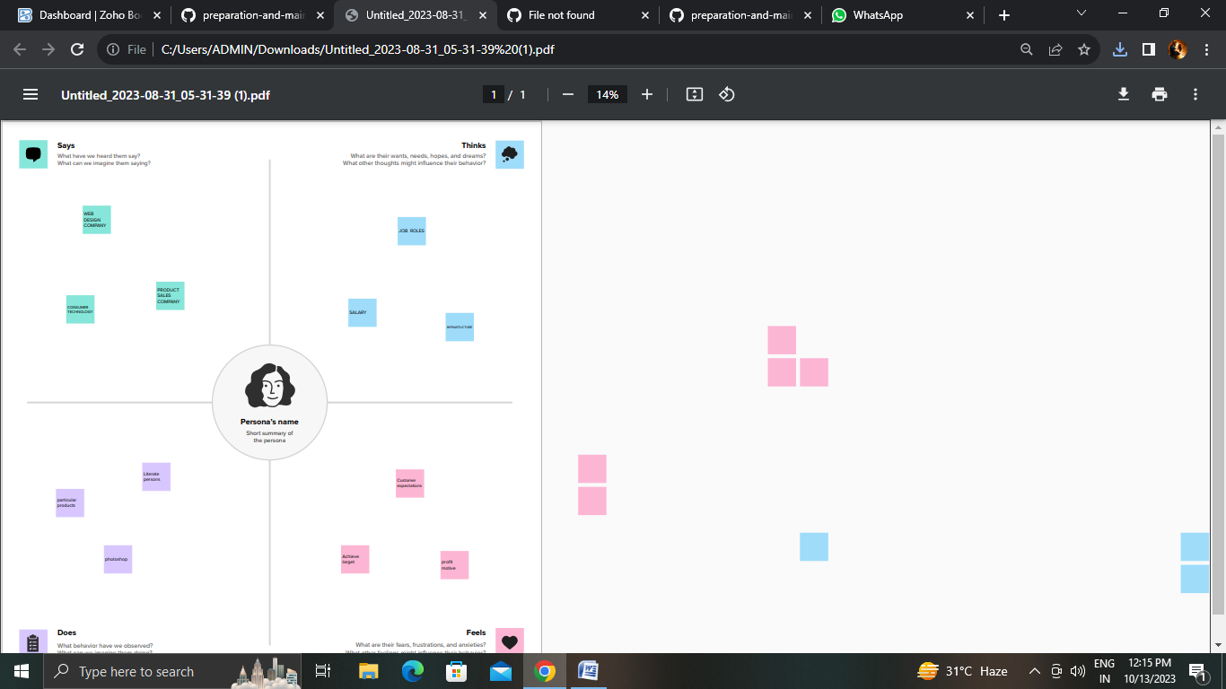
   3. Ideation & Brainstorming Map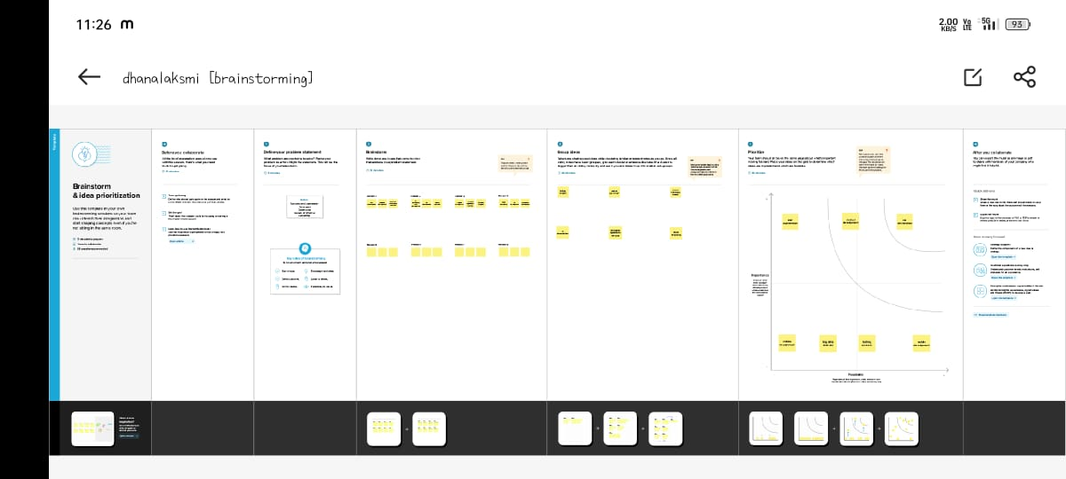

# RESULT

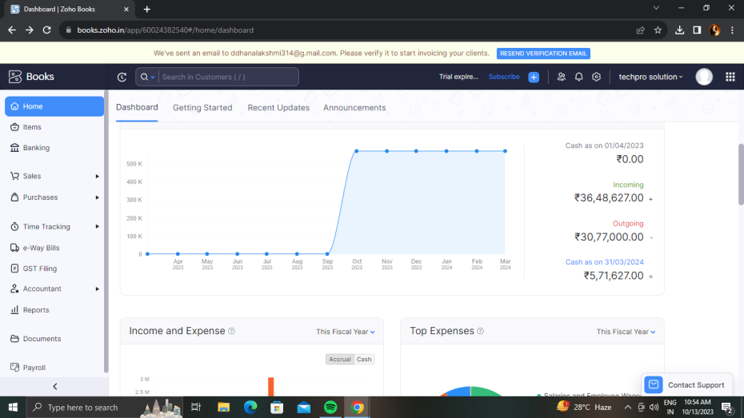

# ADVANTAGES & DISADVANTAGES

ADVANTAGES

Increase creativity

Save times

Technology helps improve service

DISADVANTAGES

Unemployment

Data security

People get distracted easily

# APPLICATIONS

The areas where this solution can be applied

# CONCLUSION

# We strive to be trusted partner as an IT solutions provider we are committed to achieve customer business objectives by delivering professional services and adopting innovative technologies

# FUTURE SCOPE

# To channelize the knowledge, expertise and the experience that has gained over the year from recommending IT products and effective solutions for our customers. Deep industry knowledge and exceptional technical expertise combined with best business ethics makes techpro the global leader in IT service and management consulting.

# APPENDIX

A. Source Code

Attach the code for the solution built.